**Detailed Proposal**

**of**

**Greenbee Fundraising Mobile Application v1.0**

**Contents**

1 Company Profile 3

1.1 About Us 3

1.2 Our Expertise 3

1.3 Our Clients 3

1.4 Quick Stats 4

1.5 Achievements Awards 4

1.6 Journey so Far 4

1.7 Few Advantages of using WebMobril 5

1.8 Similar Projects 5

2 Deliverable Components 5

3 Project Estimation 6

4 Commercial and Payment Terms 6

5 Roles and Responsibilities 7

6 Delivery Model 7

6.1 Work Model 7

6.2 Project Methodology & Timelines 8

7 Other Terms and Conditions 8

8 Escalation Matrix 9

# Company Profile

## About Us

WebMobril Technologies Pvt. Ltd. is an IT service company providing a wide range of solutions in several IT domains and Technologies. We started back in 2016 as a Website Development, Mobile App Development, and Digital Marketing Company by time extended our services in Game App Development and Cyber Security Services.

Our Head office is based in Noida near to the capital city Delhi, we are empowered by our Development Centers based in three locations which are Bengaluru (Silicon city of India), Chandigarh, and Indore. We have also got ourselves registered in the New Jersey USA, in 2019.

## Our Expertise

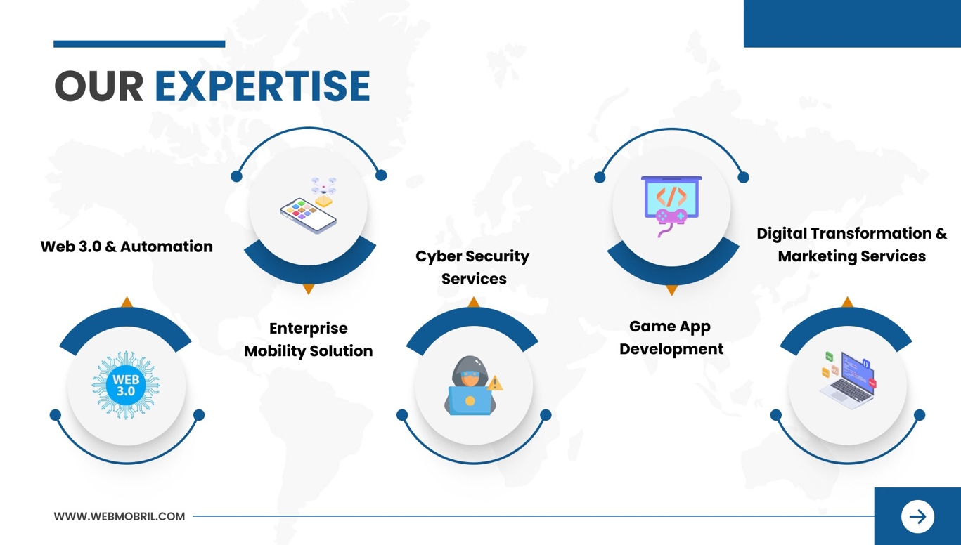

## Our Clients

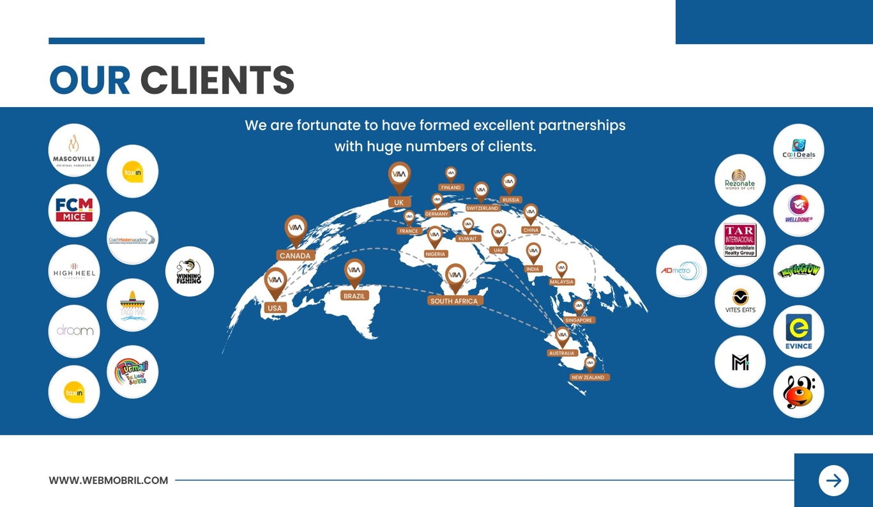

## Quick Stats

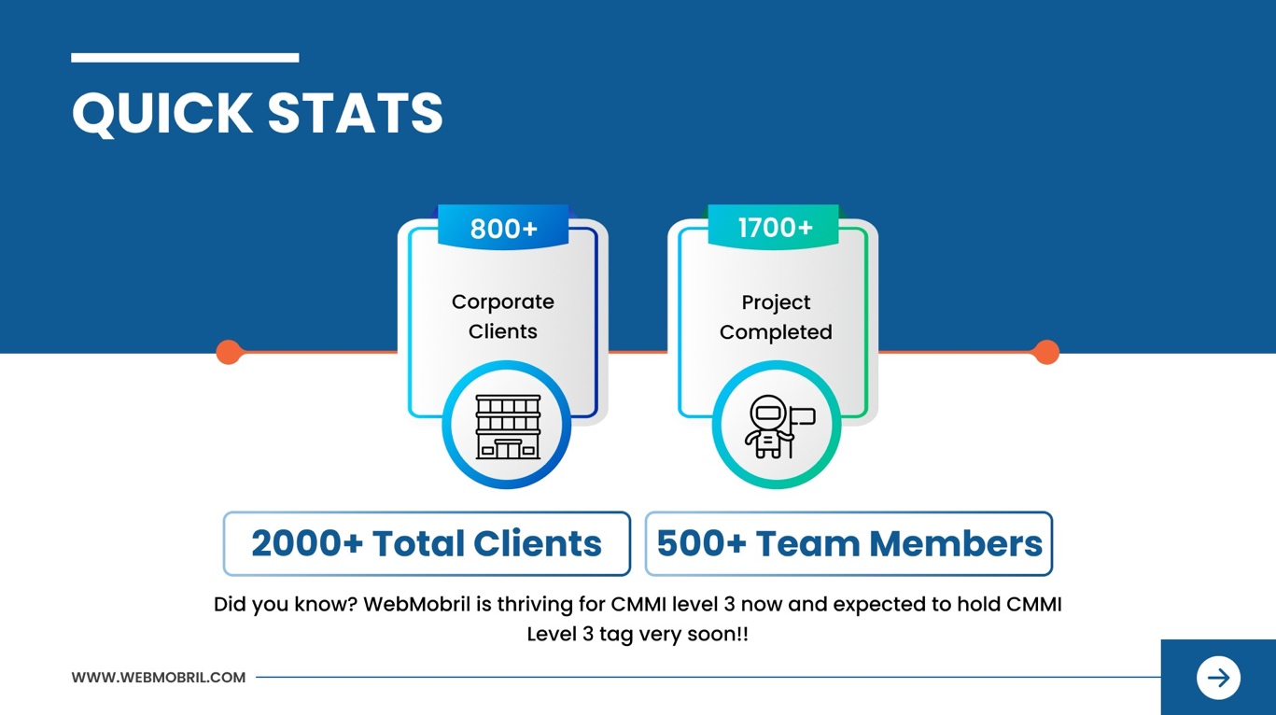

## Achievements Awards

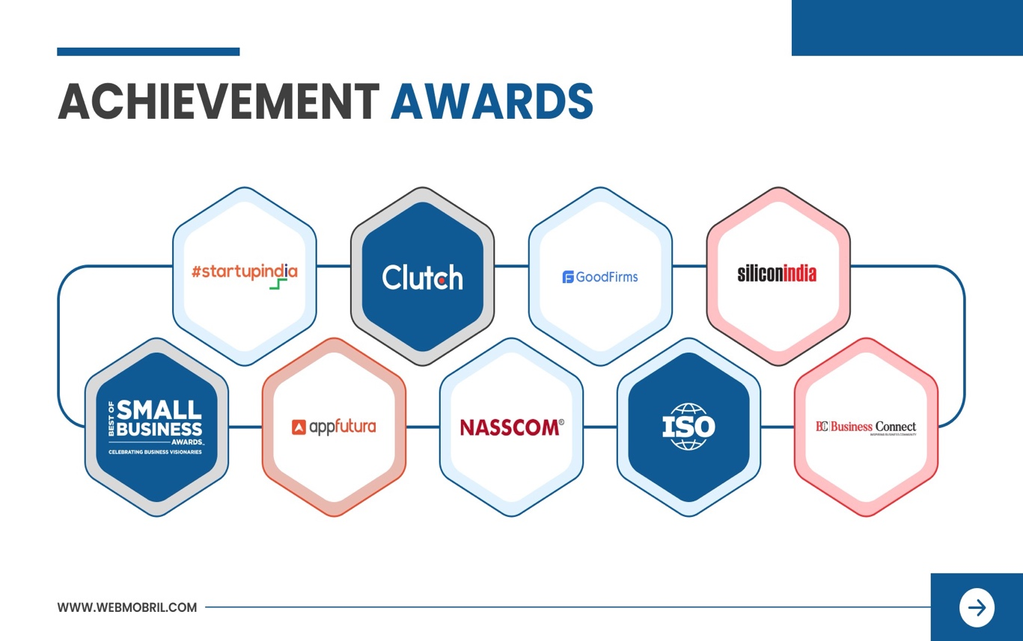

## Journey so Far

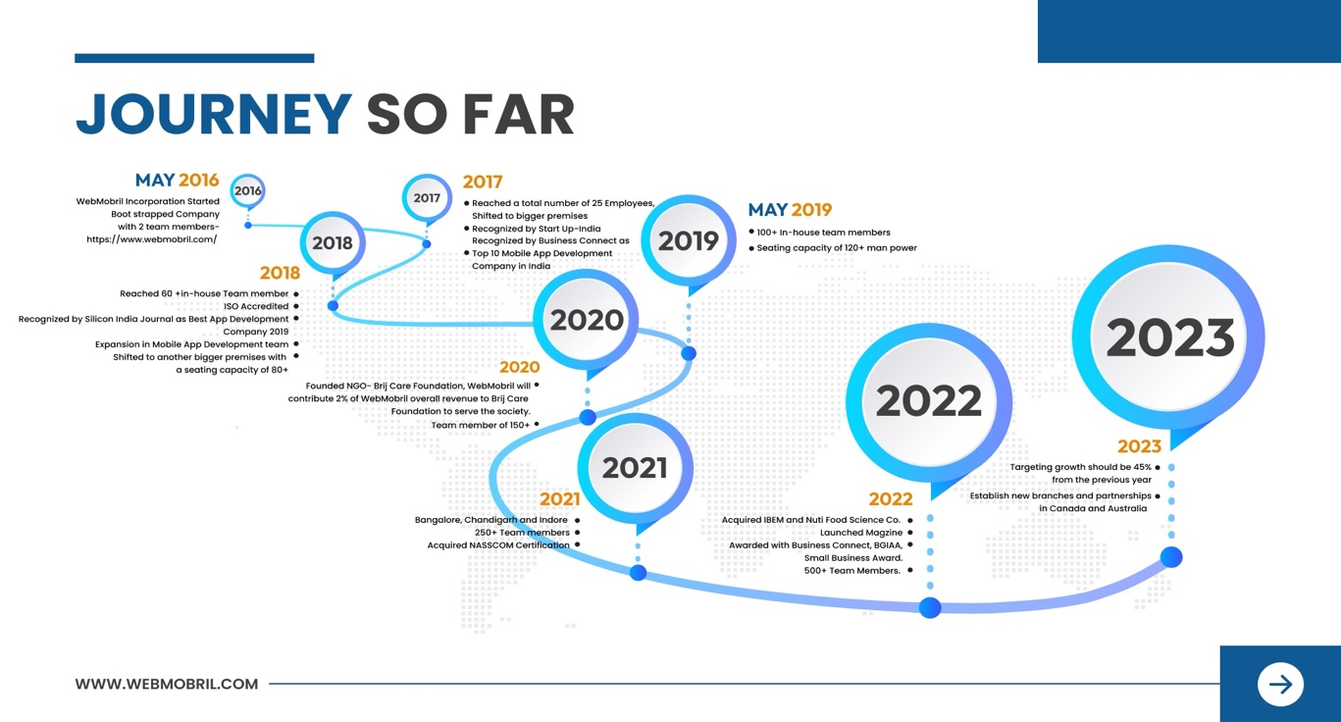

## Few Advantages of using WebMobril

* Quick Response Time
* Specialized team - Certified Professionals
* Proven Track Record
* Verifiable References
* SLA Based agreements
* Specialized and focused service area
* Agile Methodology
* World class infrastructure
* ISO Based Processes

## Similar Projects

List of similar projects which are LIVE with below details: -

* Project Name
* Project Link
* Project Description (In Brief)
* Deliverables
* Technology Used

# Deliverable Components

These are the deliverables component that will be delivered post completion of the project.

|  |
| --- |
| **Deliverables Components** |
| **Business Analyst:** Proposal, UFD, Gantt Chart and WBS |
| **Project Management:** Delivery Plan, Sprint Plan |
| **QA Team:** Test Cases and Test Results |
| IP & Source Code Delivery |

# Project Estimation

**The proposed quote is USD 10000 only and the estimate of the total effort would be 25 Man Days.**

**On your approval and confirmation, we will be working on a project delivery schedule based on our resources’ allocation plan.**

# Commercial and Payment Terms

|  |  |  |  |
| --- | --- | --- | --- |
| **S. No.** | **Milestones** | **%** | **Amount (USD)** |
| 1 | Mobilization Fund | 25 | 2500 |
| 2 | On Design Completion | 25 | 2500 |
| 3 | On 50% Completion of Project | 25 | 2500 |
| 4 | On User Acceptance Testing Initiation | 15 | 1500 |
| 5 | On Final Delivery- Project Completion (Before LIVE) | 10 | 1000 |
|  | **Total** | **100** | **10000** |

**Payment Terms and Conditions**

* This quote is valid for 4 weeks from the proposal date.
* In case the payment is done via PayPal then 4.5% of the PayPal fee will be applicable.
* Additional payment processing fee will be applied as per the policy of your respective bank (if payments are processed through Bank Wire Transfer).
* Project Plan to be defined at the beginning of the project and the invoice shall be raised accordingly.
* All the invoices have to be cleared within five business days post which it will attract penalty at 2% per month of the total Project Cost.

# Roles and Responsibilities

|  |  |  |  |
| --- | --- | --- | --- |
| **S. No.** | **Deliverables & Details** | **WebMobril** | **James Thomas** |
| 1. | Logo |  |  |
| 2. | Staging Server (Development) |  |  |
| 3. | Source Code protected under NDA & IPR |  |  |
| 4. | Project Collaboration and Management Tool |  |  |
| 5. | Deployment Servers, Domain & Account Details |  |  |
| 6. | Third-Party SDK, Tool, API, Module or Component |  |  |
| 7. | Design Sign-off on shared designs |  |  |
| 8. | Testing of the system development release testing by their users starting 15 working days before the system release date |  |  |
| 9. | Feedback on system flow within 2 business days of receiving the web and mobile system flow. |  |  |

**Note: -** **James Thomas** will ensure that the hosting service provided is compliant with the requirements for the hosting server provided by WebMobril.

# Delivery Model

WebMobril adopts and adheres to the Delivery Model as per the latest IT industry trends.

## Work Model

* The resources shall work from any Business Place of Webmobril in India.
* For requirement gathering, a Project Manager shall coordinate with **James Thomas** point of contact.
* Weekly meeting shall be set up for status meeting between the **James Thomas** (Point of Contact) and Webmobril Point of Contact (Project Manager).
* Project Manager & Project Expert shall be the point of contact for any technical issues related to the project.

## Project Methodology & Timelines

* Project shall be executed on Agile Methodology, which promotes adaptive planning, evolutionary development and delivery, a [time-boxed](http://en.wikipedia.org/wiki/Timeboxing) iterative system approach, and encourages rapid and flexible response to change
* As we gather better understanding of the project, a project plan shall be created with tentative timelines mentioned.
* Our Methodology… Best quality with the best design

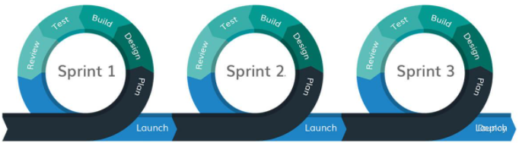

# Other Terms and Conditions

* Project Start: Project would start within one week of awarding
* This proposal will be only valid once we receive a signed copy of the same from **James Thomas‘s** end.
* Deliverables listed in the proposal above will be referred to during the development of the project.
* Any new features, additional modules, major changes in workflow or any other element which is out of scope as mentioned in the document **Technical Specification Annexure – I** would be reevaluated.
* In case the need to make the resource(s) available onsite for study/delivery or any other purpose the cost of travel, boarding, lodging and daily expenses as per actuals shall be borne by **James Thomas.**
* WebMobril will provide 1 design concept for Design work and there will be 2-3 revisions that can be done as per **James Thomas’s** remarks. If more revisions are required then those will be on chargeable basis.
* WebMobril would only provide dummy content however the actual content would be uploaded or published by the **James Thomas** only.
* WebMobril is not responsible for the delay of the project if the necessary information required by **James Thomas** like API's information, third party plug-ins, Payment gateways and shipping gateways info etc. is not provided within the stipulated timeline by **James Thomas.**
* WebMobril is not responsible for the delay caused by the malfunctioning of any third-party software integrated with some other system appreciated works.
* General features, not described in detail, will be carried out as per the industry standards.
* Neither party can hire/contact/work with either of its employees/resources /former employees directly or indirectly during the term of this contract and for 5 years without the written permission from the directors of the company.
* **If project is put on-hold due to what so ever reason, then the total efforts put upon by the WebMobril has to be paid by James Thomas**

# Escalation Matrix

|  |  |  |
| --- | --- | --- |
| **Level I** | **Level II** | **Level III** |
| **Project Expert** | **Project Manager** | **Delivery Head** |
| Vijay Thakur | Anil Saraswat | Viveka Upadhyay |
| vijay.thakur@webmobril.com | anil.saraswat@webmobril.com | viveka.upadhyay@webmobril.com |